Day 3 Activity 3

- Compare regular trains and bullet trains in China. Below is a time table shown in the 兰州 (lánzhōu) train station in China. Answer the following based on the table.

- 兰州(lánzhōu)离哪儿最远？
- 兰州(lánzhōu)离哪儿最近？
- 从兰州(lánzhōu)到广州坐高铁要多久？坐火车呢？
- 从兰州(lánzhōu)到郑州坐高铁要多少钱？坐火车呢？

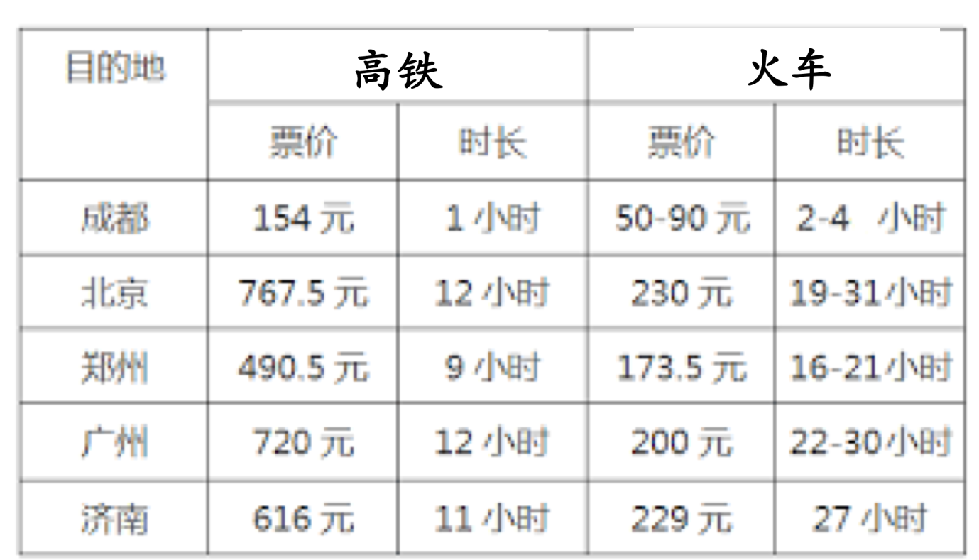

（2） Read a website. Answer the following questions based on the information of the website.

- Is this information about a regular train or a bullet trains?
Circle the answer on the webpage.
- Where are the departure city and arriving city included in this page?
Draw a box around the answer on the webpage.
- On which date will the train leave?
Draw a triangle around the answer on the webpage.
- At what time will the train leave? underline the date.
- How long will it take to get to the arriving city? Circle the answer.
- What is the number for this train? Underline the train number.
- What are prices for the tickets? Draw a box around the answers.

